Actuation: Motor Driver Circuits (Left & Right)

The motors in the front of the robot and the back of the robot are utilized to allow the robot to move left or right. This means that the motors must be able to rotate in both directions. To do so we will need:
- 2 DC motors
- 8 BJT NPN Transistors
- 8 IN4001 Diodes
- 10 Resistors
- 9V Battery
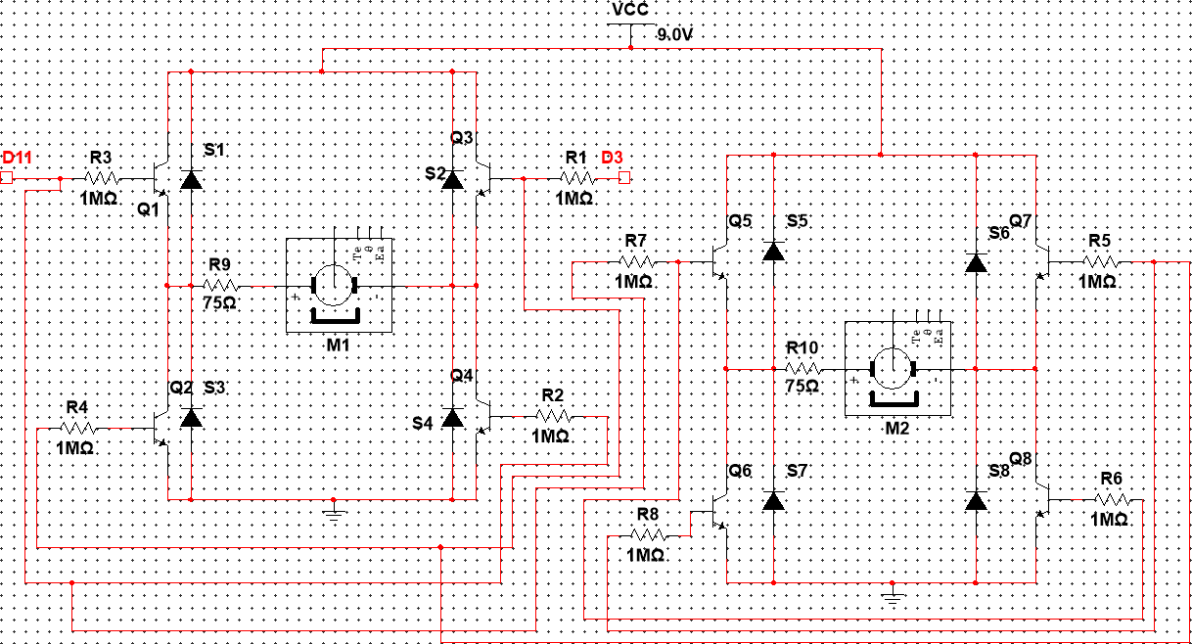
This is an H-bridge bidirectional dc motor control. Each motor contains 4 BJT transistors which with certain combinations allows the current to flow to the motor in such a way that it rotates in two different directions. To rotate the motor in one direction one of the Arduino pins is set to HIGH, with a voltage of 3.3 V and the other to LOW, 0 V. For example, setting pin D11 to HIGH and D3 to LOW, current flows to the base of transistors Q1 and Q4 thus allowing current to flow from Vcc, through transistor Q1, through motor M1 and through to transistor Q4. Additionally, the motor on the back of the robot will have transistor Q5 and Q8 turned on and Q7 and Q6 turned off, thus causing this motor to rotate in the same direction allowing the robot to move left or right. Doing the opposite and setting D3 HIGH instead causes the current to flow the opposite direction relative to the motor thus causing it to rotate the other direction and moves the robot to the other direction.
The NPN BJT transistors were selected to act as a switch and to amplify the current that enters from the Arduino through the base terminal. NPN BJTs were selected instead of PNP because of the faster transitions of electrons, thus making this type of BJT more suitable for quick switching between the turning ON and OFF the motors. When the base current is zero, the transistor acts as an open switch to allow the other transistors to act as closed switches when their base currents are above the base current threshold. They act as amplifiers since the current flowing through it from collector to emitter is proportional to the base current and much greater than it, so a small base current can allow a large current to flow through the motor.
When the current flow through the motor suddenly changes (due to turning it off or on) there is an induced EMF which is produced in the conducting coil which rotates in the motor. This opposes the supply voltage thus a voltage spike is sent the opposite direction. This may damage the Arduino and the transistors thus connecting a diode parallel to the motor blocks this voltage spike. The motor is obviously utilized to allow the robot to be mobile. Lastly, the resistors are there to limit the base current to a certain range and the current flowing through the motor, to stop the motors from rotating at high speeds to allow the sensors enough time to function and send corresponding commands to the actuators. The DC motor needs approximately 0.12A to run, therefore, we will require a 75 Ω resistor in series with the motor. However, the resistances of the resistors are not finalized since they depend on the rating of the motor (how much current is needed for the specific RPM).

